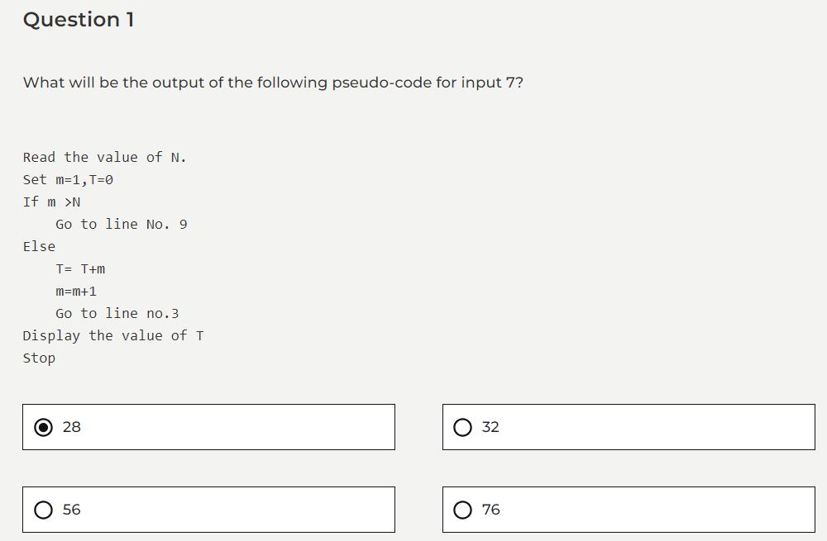

#include<stdio.h>

int f(int n)

{

static int a =0;

if(n<=0)

{

return 1;

}

if(n>3)

{

a=n;

return f(n-2) +2;

}

return f(n-1) + a;

}

int main()

{

printf("Result: %d",f(5));

return 0;

}



19



9



2



18

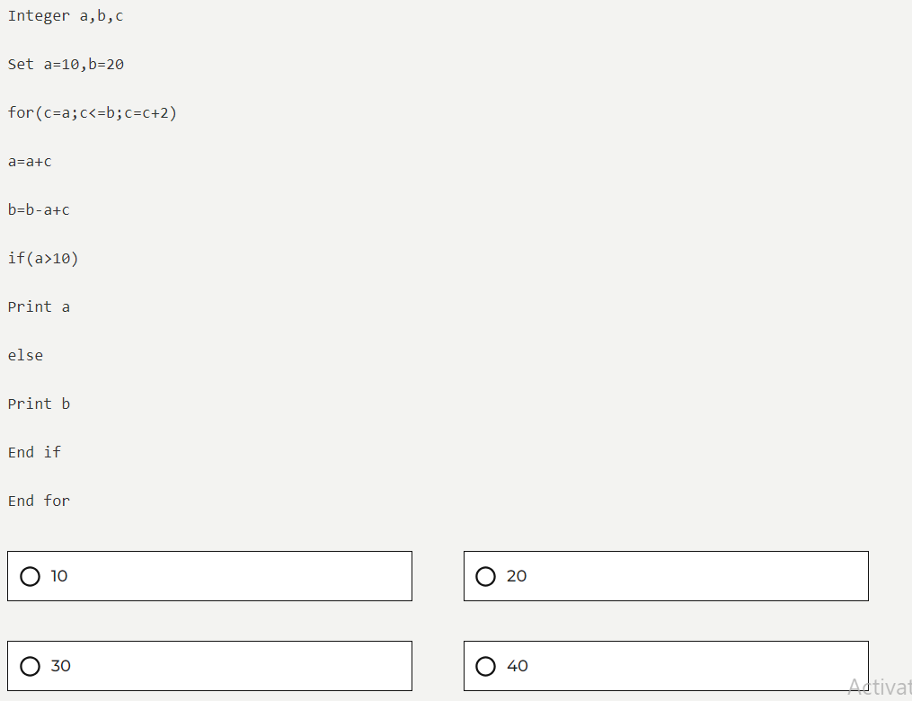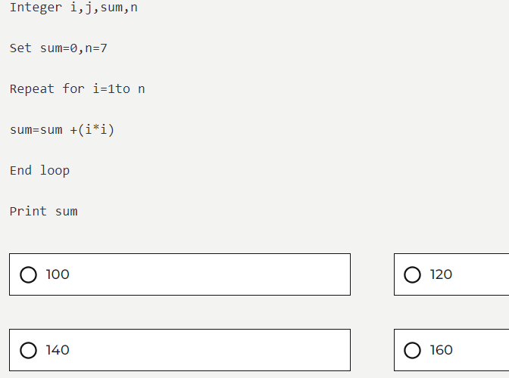 A)91 But My is 92 class Ts

{

public static void main(String args[])

{

int i,j,sum=0,n=7;

for(i=1;i<n;i++)

{

sum = sum +(i\*i);

}

System.out.print(sum);

}

}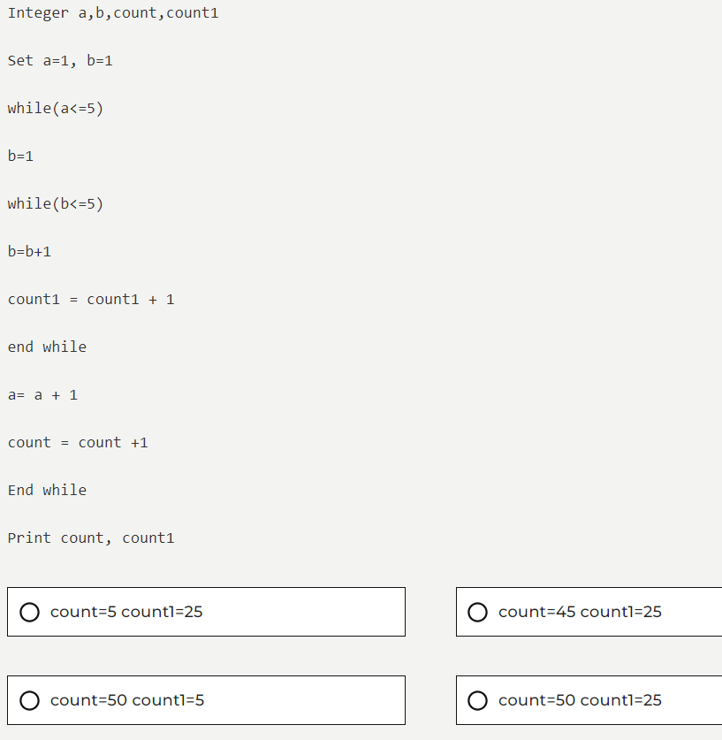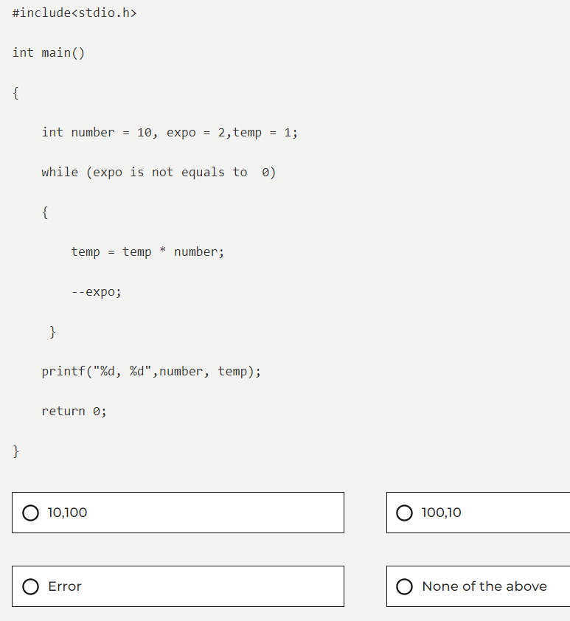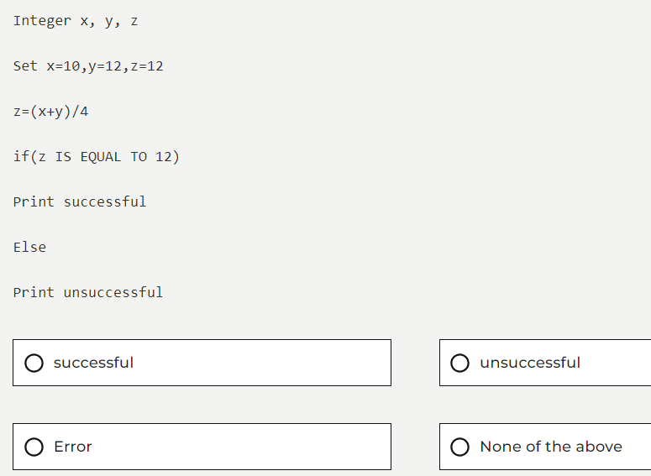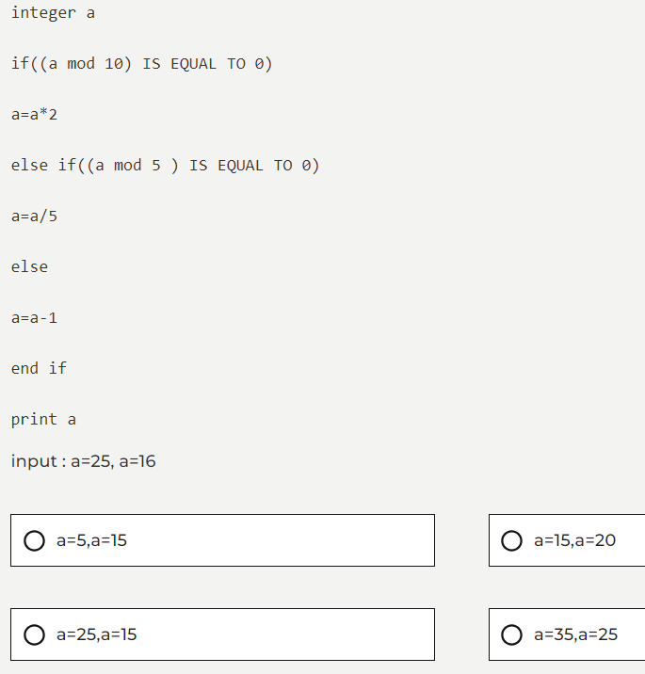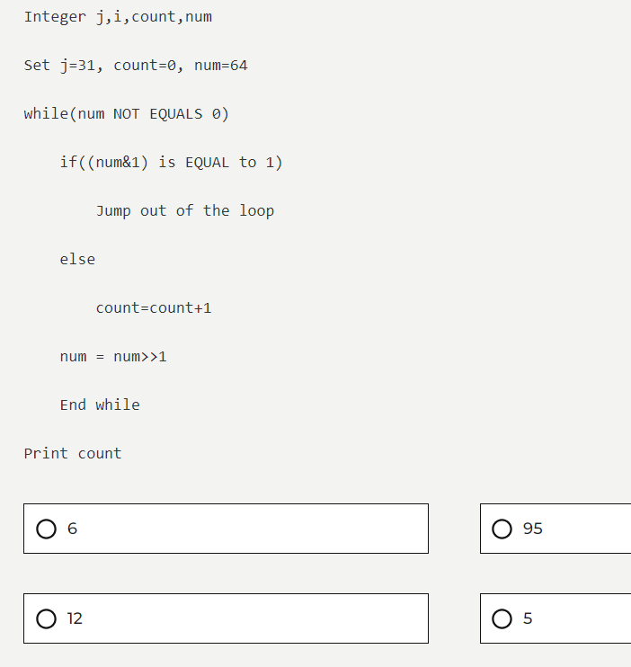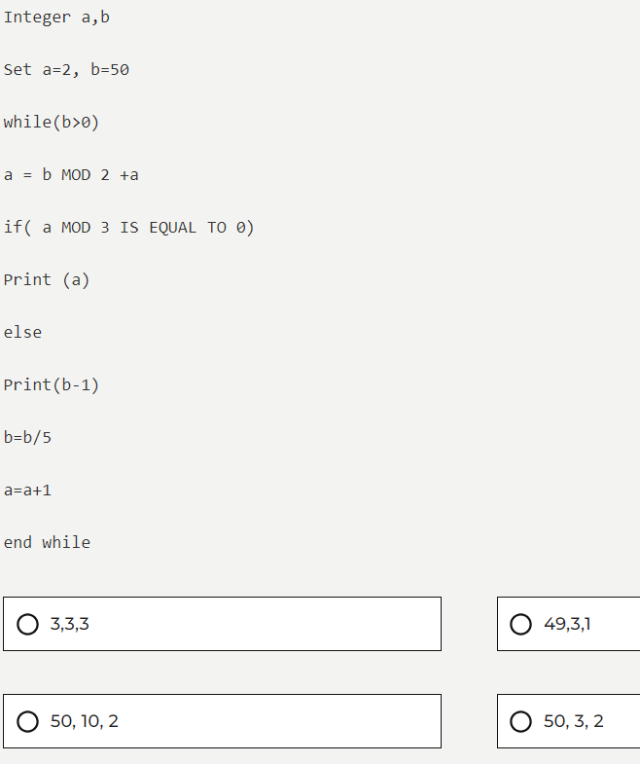bstree(\*tree)

{

while((tree->left !=null)&&(tree->right !=null))

{

if(tree-> root)

bstree(tree->left);

else

return (1);

if(tree->right > tree->root)

bstree(tree->right);

else

return (1);

}

return (0);

}



Bubble sort



Tests whether a binary tree is a Binary Search Tree



Prim’s algorithm



None of the mentioned options. 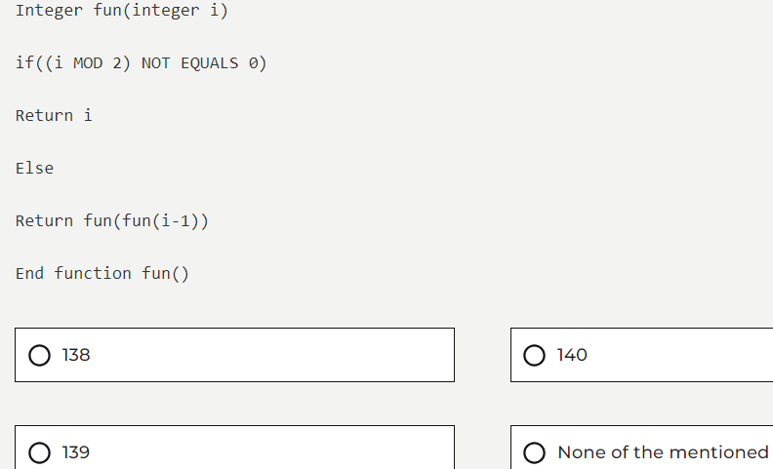Integer a,b,c

Set a=6,b=84

while(b>0)

b=b/2

a=a+6

c=a+b

while(c>40)

if(c mod 2 IS EQUAL TO 0)

Print a

else

Print b

c=c/10

End while

End while

Print c



48, 4



12, 4



12, 1, 4



12, 1, 48, 4

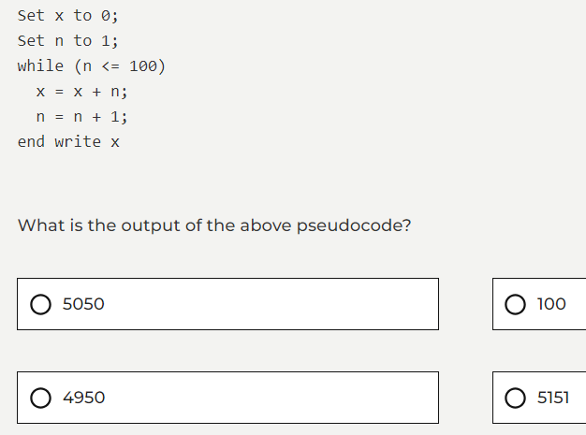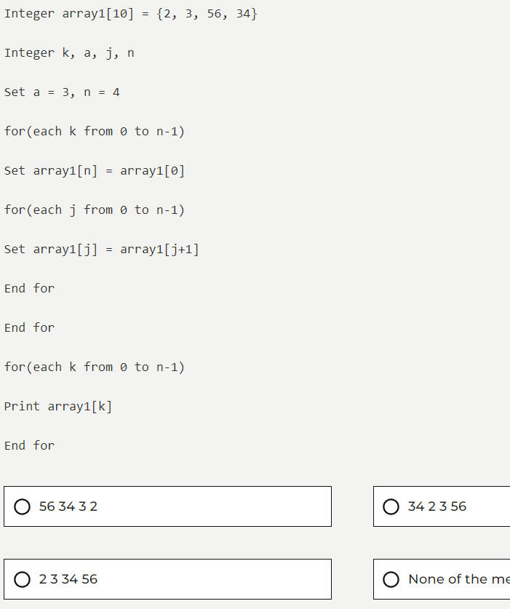

A)156

